**Advanced Computer Networks and Security**

**Ramesh Vottem**

**700766378**

Creating the container using yml file To bring all the container to Active status we use dcup and to detach the terminal we use –d

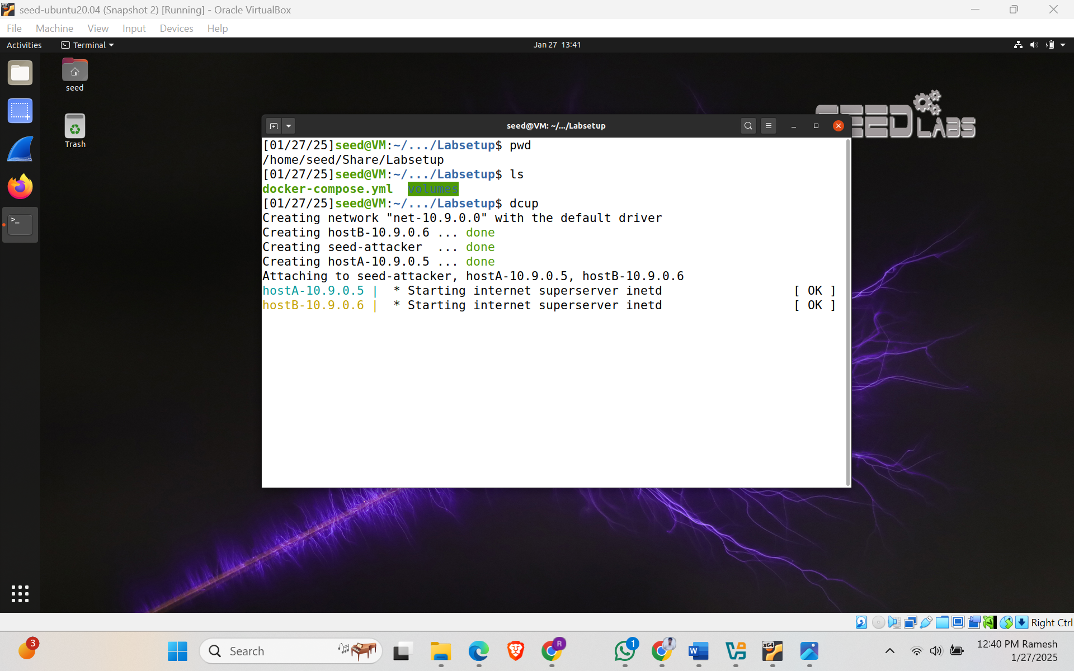

Using docker containers in VM to to perform sniffing and spoofing of packets. Used dcbuild, dcup and dcdown commands to start, run and shutdown the containers. Used **ifconfig** command to find the interface id.

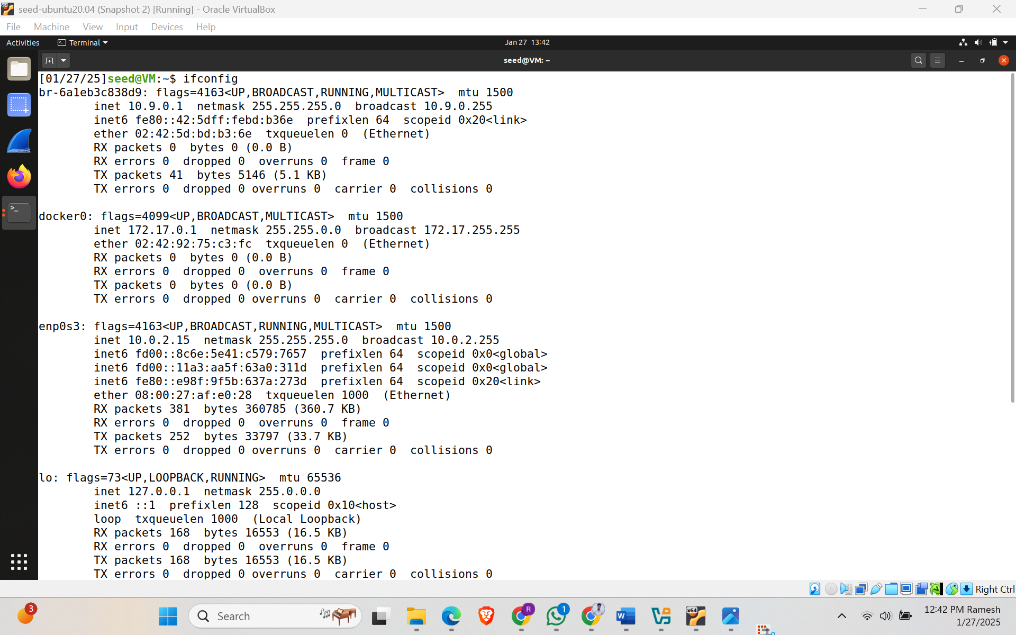

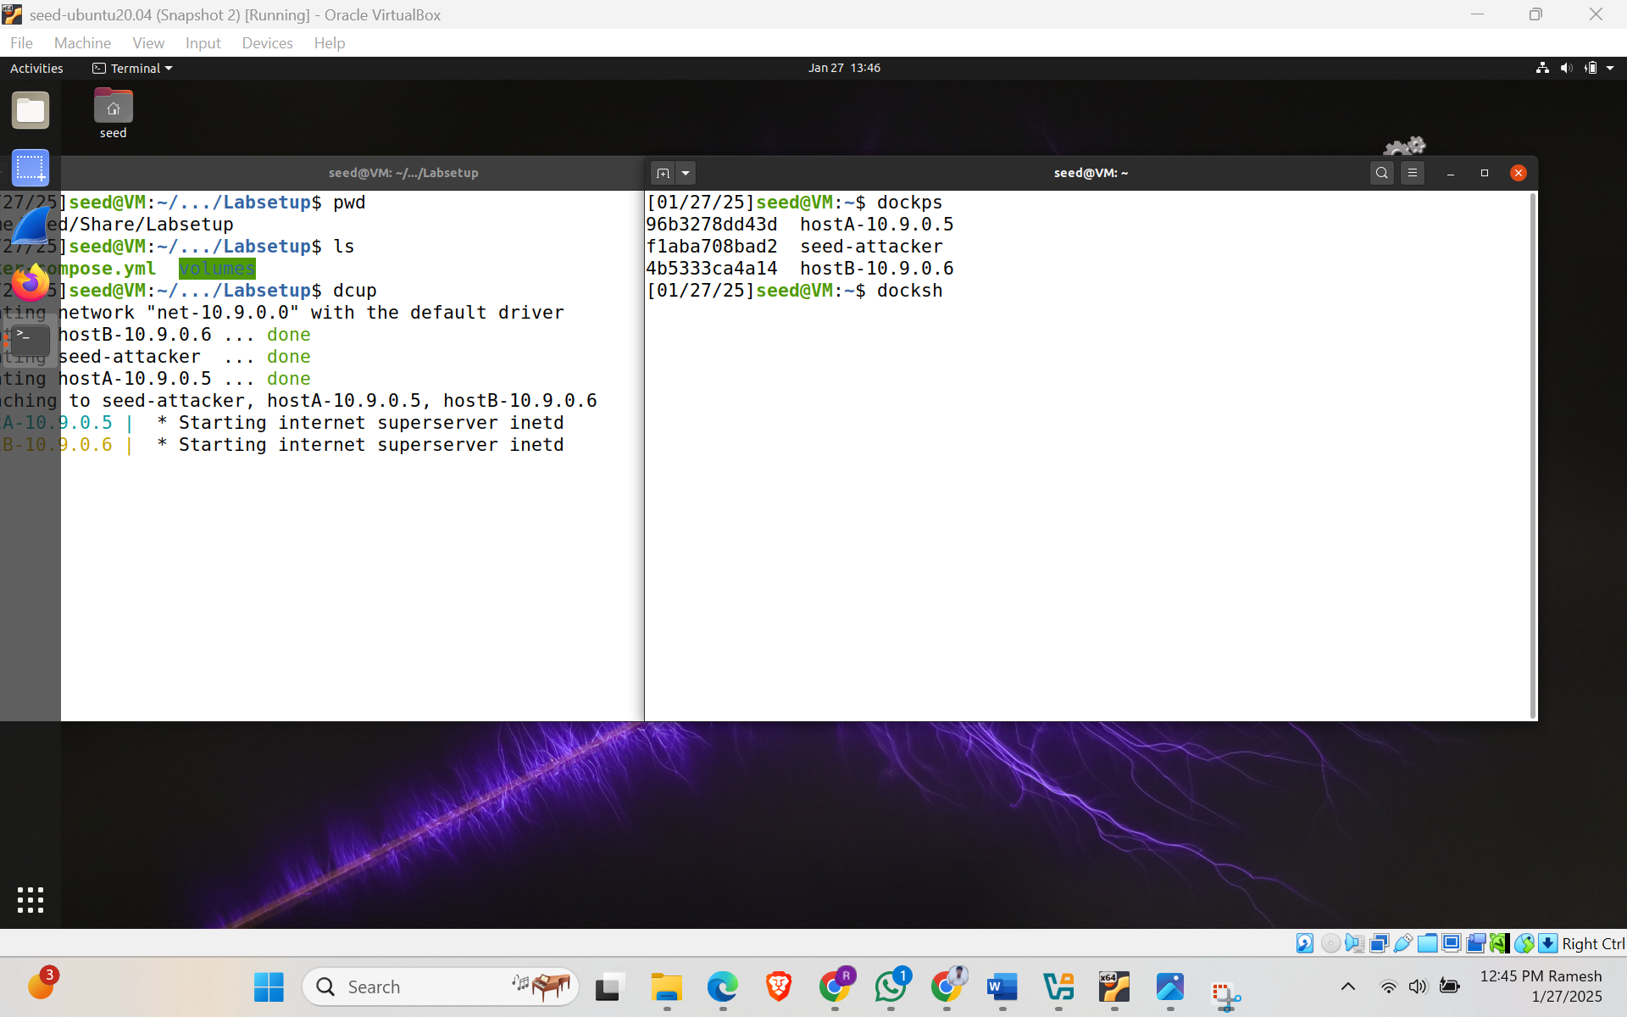

**Task 1: Using Scapy to sniff and spoof**

**Code:**

#! Usr/bin/env python3

from scapy.all import *

a = IP()

a. show()

The IP() method creates and returns a new IP default and empty packet. Show() method displays the contents of the packet.

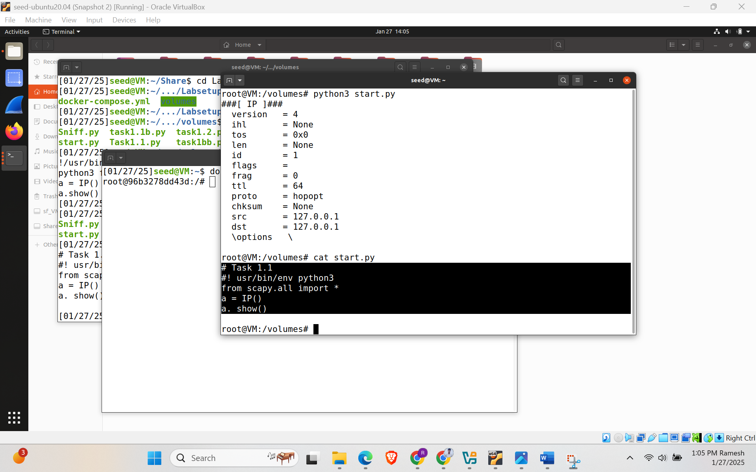

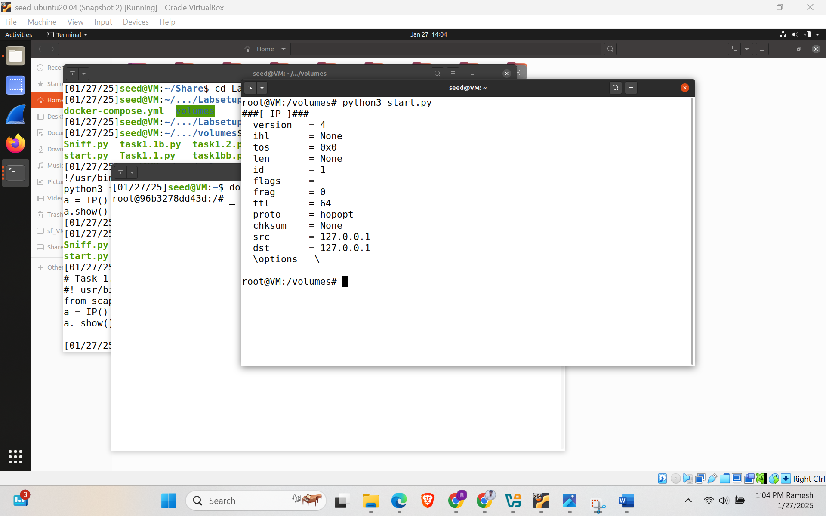

Task 1.1 Sniffing packets

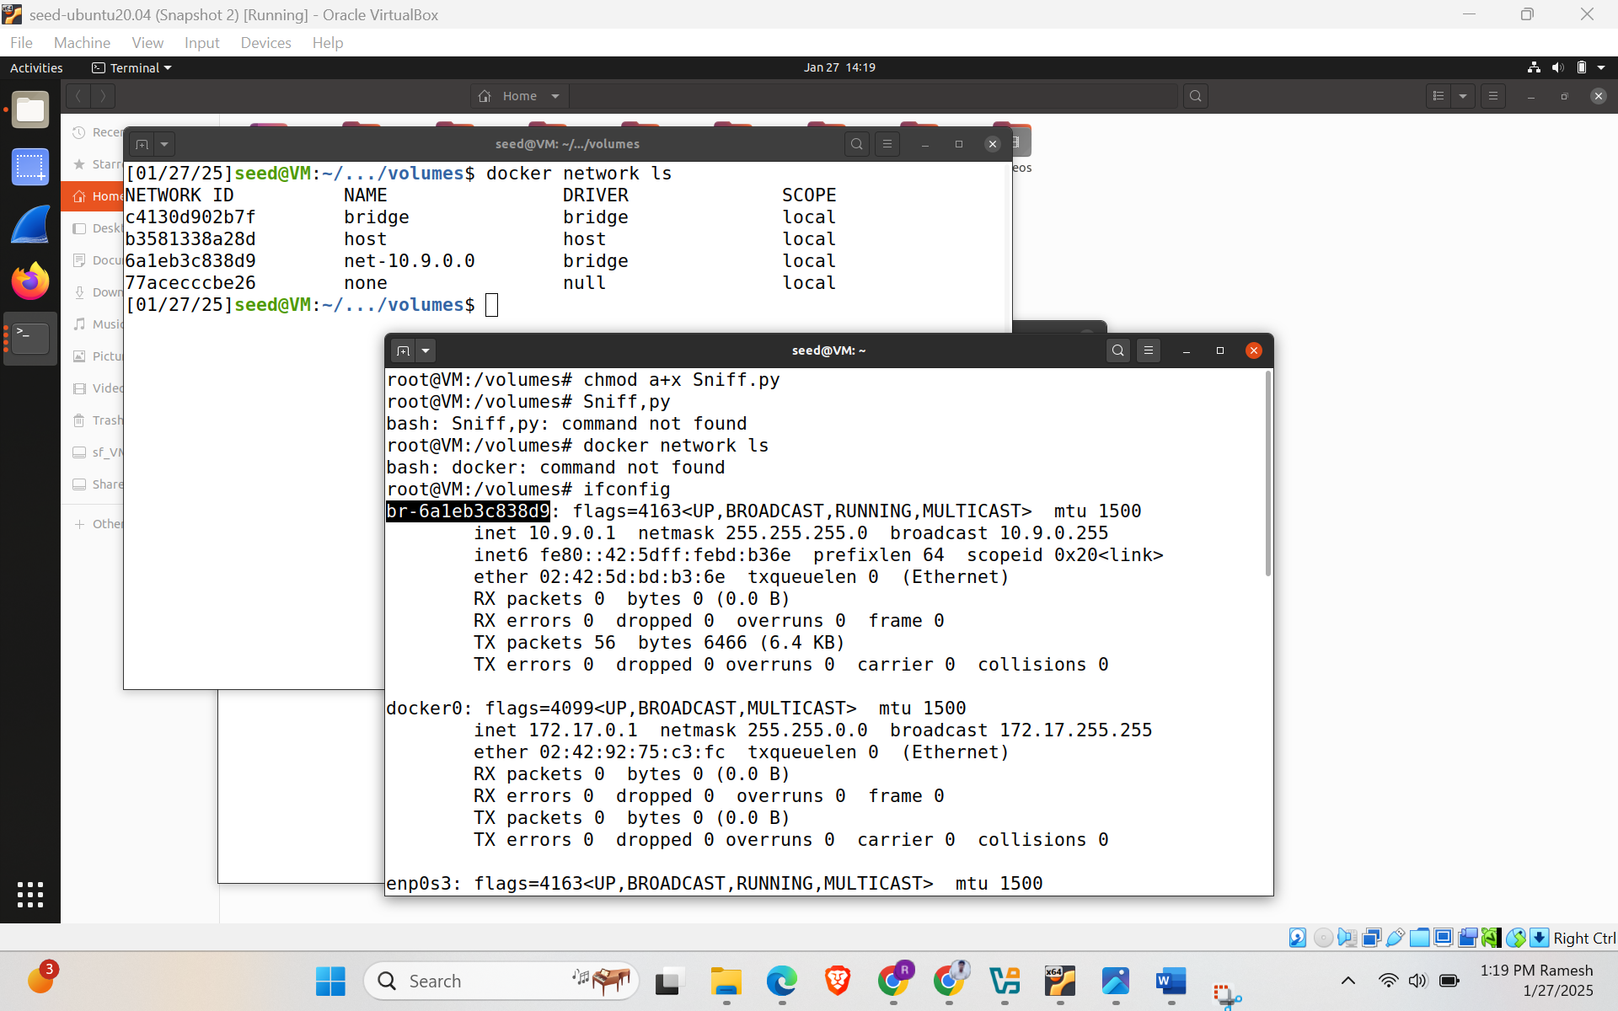

1. Capture only the ICMP Packet

Code:

!/usr/bin/env python3

from scapy.all import *

def print_pkt(pkt):

pkt.show()

pkt = sniff(iface='br-6a1eb3c838d9', filter='icmp', prn=print_pkt)

When we run in VM

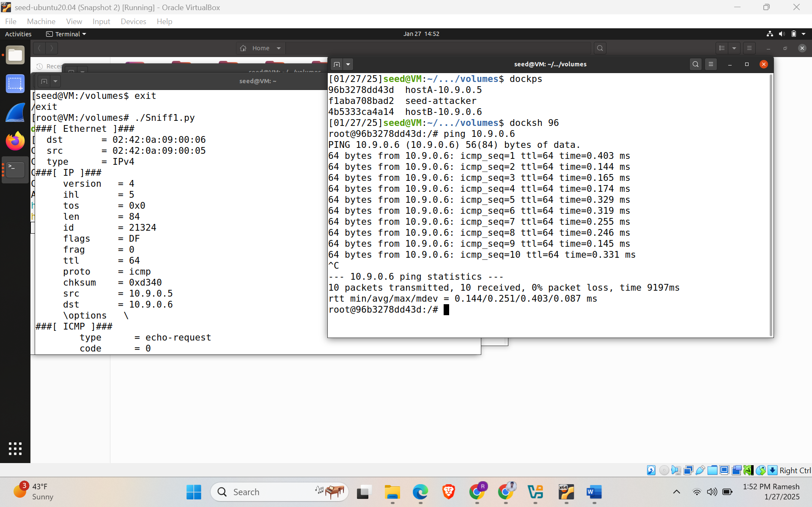

When Switched into Seed, Then it shows as Operation Not Permitted.

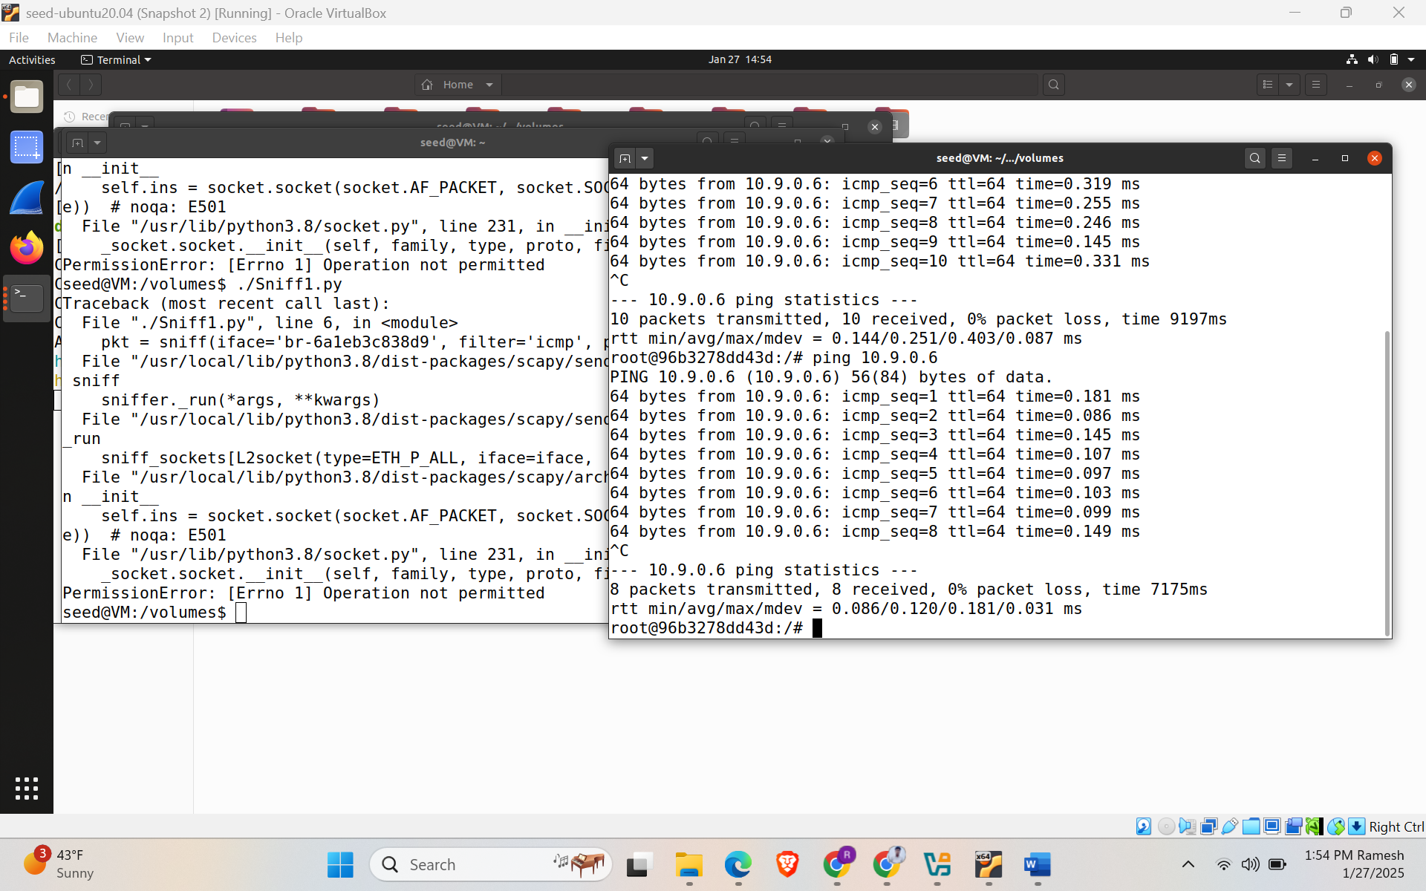

b. capture any TCP packet that comes from a particular IP and with a destination port number 23.

Code:

#!/usr/bin/env python3

from scapy.all import *

def print_pkt(pkt):

pkt.show()

pkt = sniff(iface='br-6a1eb3c838d9', filter='tcp && src host 10.9.0.6 && dst port 23', prn=print_pkt)

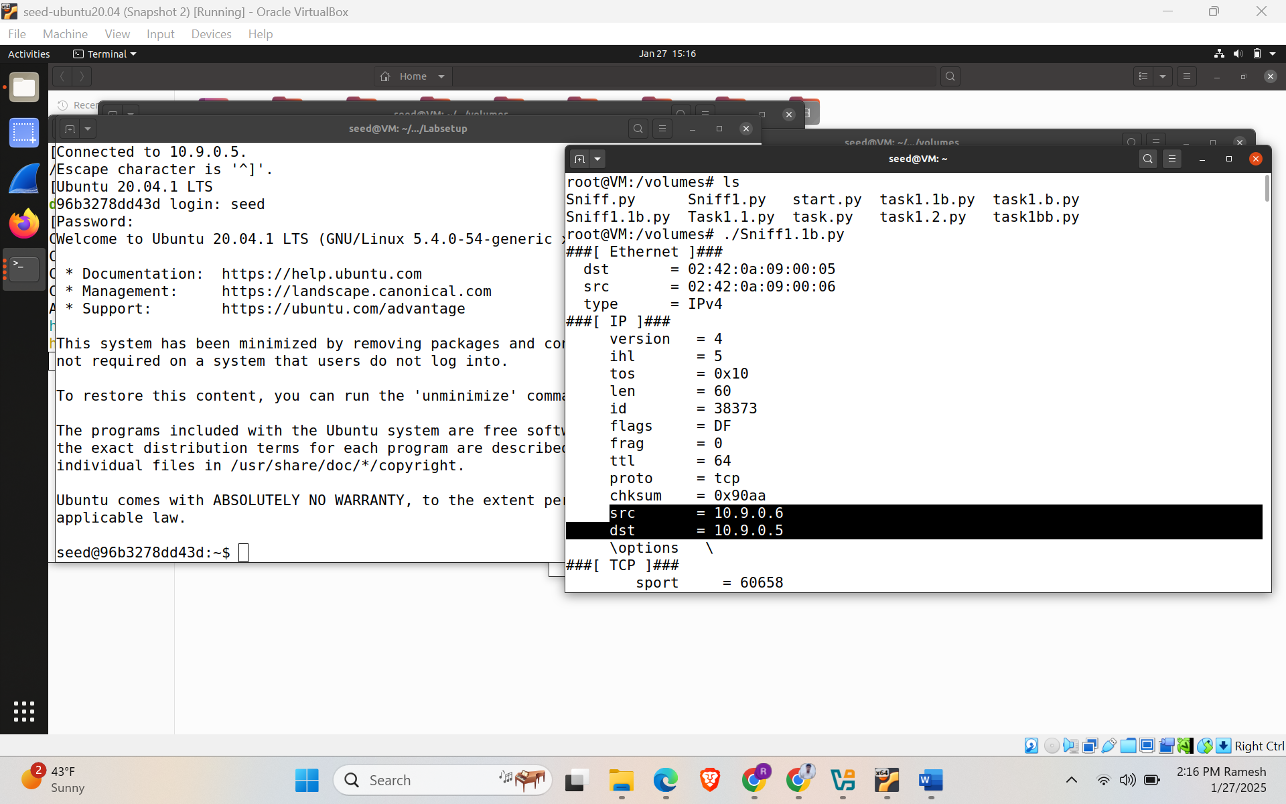

c. Capture packets comes from or to go to a particular subnet. You can pick any subnet, such as 128.230.0.11

Code:

#!/usr/bin/env python3

from scapy.all import *

def print_pkt(pkt):

pkt.show()

pkt = sniff(iface='br-6a1eb3c838d9', filter='net 128.230.0.0/16', prn=print_pkt)

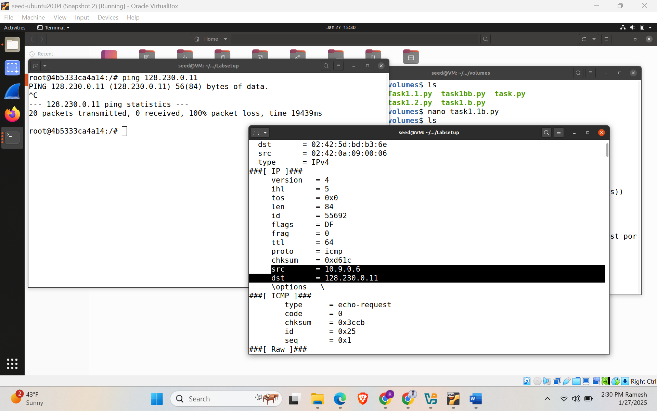

**Task 1.2: Spoofing ICMP Packets**

Code:

#!/usr/bin/env python3 from scapy.all import * a = IP()

a.src = '4.3.2.1'

a.dst = '10.0.0.6'

ls(a)

send(a/ICMP))

Used different IP 10.0.0.6 and sent an ICMP packet using random IP 4.3.2.1

Spoofed an ICMP echo request packet with an arbitrary source IP address. Initially sent packet from

4.3.2.1 to 10.0.0.6 and then packet was received by 10.0.0.6 and sent an echo reply to 4.3.2.1.

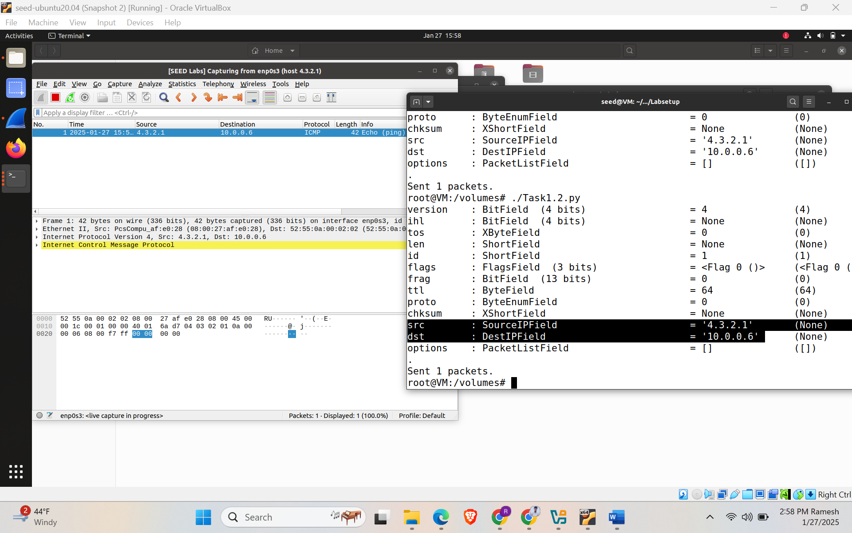

**Task 1.3: Traceroute**

**Code:**

#!/usr/bin/env python3 from scapy.all import *

import sys

a = IP()

a.dst = '8.8.4.4'

a.ttl = int(sys.argv[1])

b = ICMP()

a = sr1(a/b) print("Source:", a.src)

using this program found the number of routers it takes to send out packets from source to IP address.

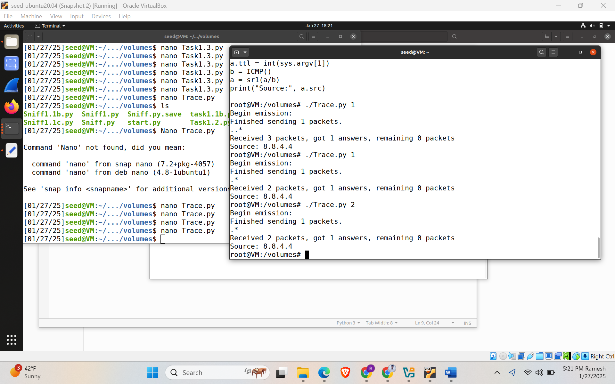

**Task 1.4: Sniffing and then Spoofing**

Code:

#!/usr/bin/python3

from scapy.all import *

def spoof_pkt(pkt):

# sniff and print out icmp echo request packet

if ICMP in pkt and pkt[ICMP].type == 8:

print("Original Packet.........")

print("Source IP : ", pkt[IP].src)

print("Destination IP :", pkt[IP].dst)

# spoof an icmp echo reply packet

# swap srcip and dstip

ip = IP(src=pkt[IP].dst, dst=pkt[IP].src, ihl=pkt[IP].ihl)

icmp = ICMP(type=0, id=pkt[ICMP].id, seq=pkt[ICMP].seq)

data = pkt[Raw].load

newpkt = ip/icmp/data

print("Spoofed Packet.........")

print("Source IP : ", newpkt[IP].src)

print("Destination IP :", newpkt[IP].dst)

send(newpkt, verbose=0)

#filter = 'icmp and host 1.2.3.4'

#print("filter: {}\n".format(filter))

#filter = 'icmp and dst host 10.9.0.99'

filter = 'icmp and host 8.8.8.8'

pkt = sniff(iface = 'br-07192431149a',filter=filter, prn=spoof_pkt)

This task has 3 scenarios with different IP addresses to ping.

In Scenario 1, we ping the IP 1.2.3.4 from src 10.0.2.15 which is a non-existing host on the internet. And receives the packet back.

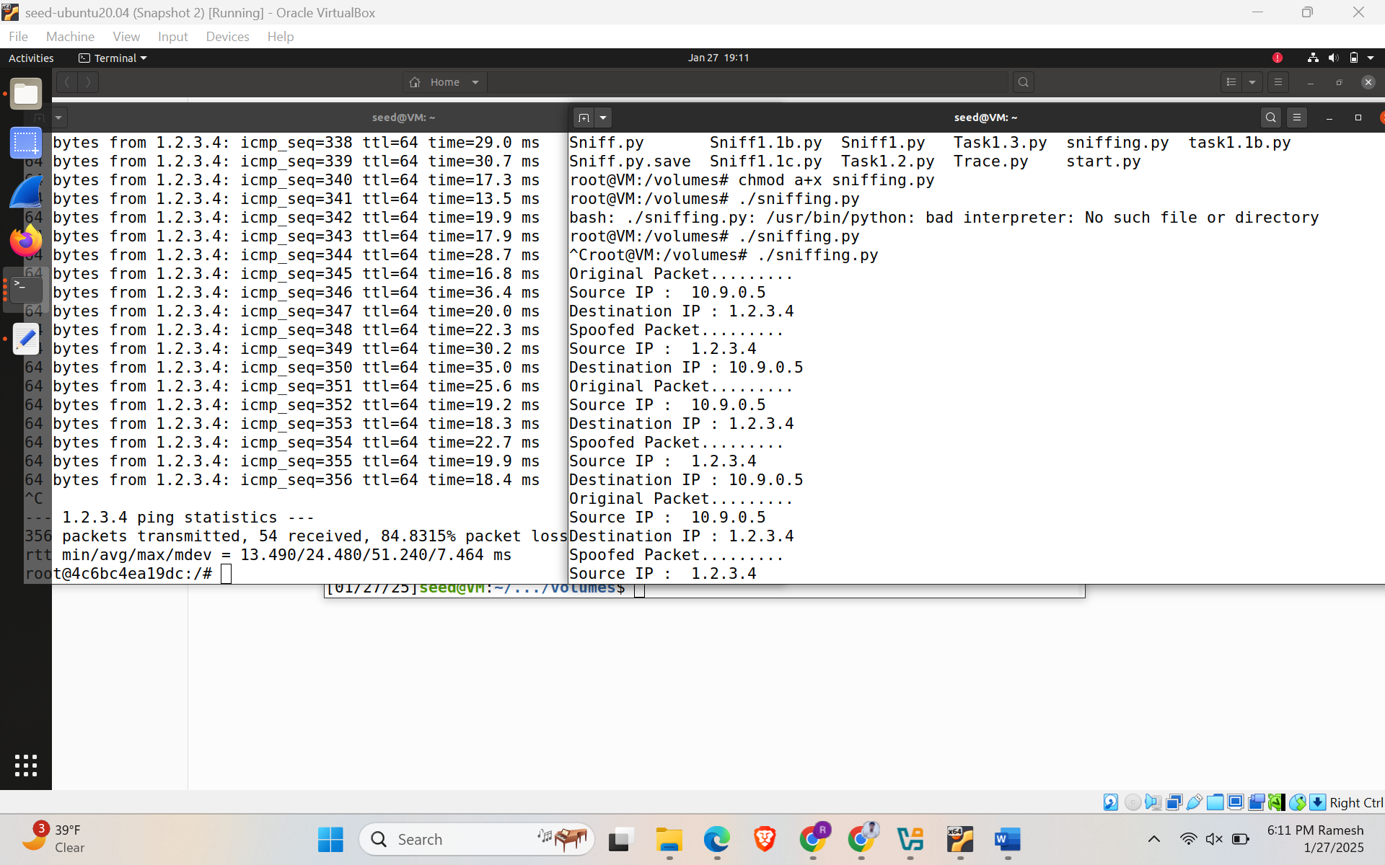

In scenario 2, we ping the IP 10.0.9.99 which is a non-existing host on the LAN.

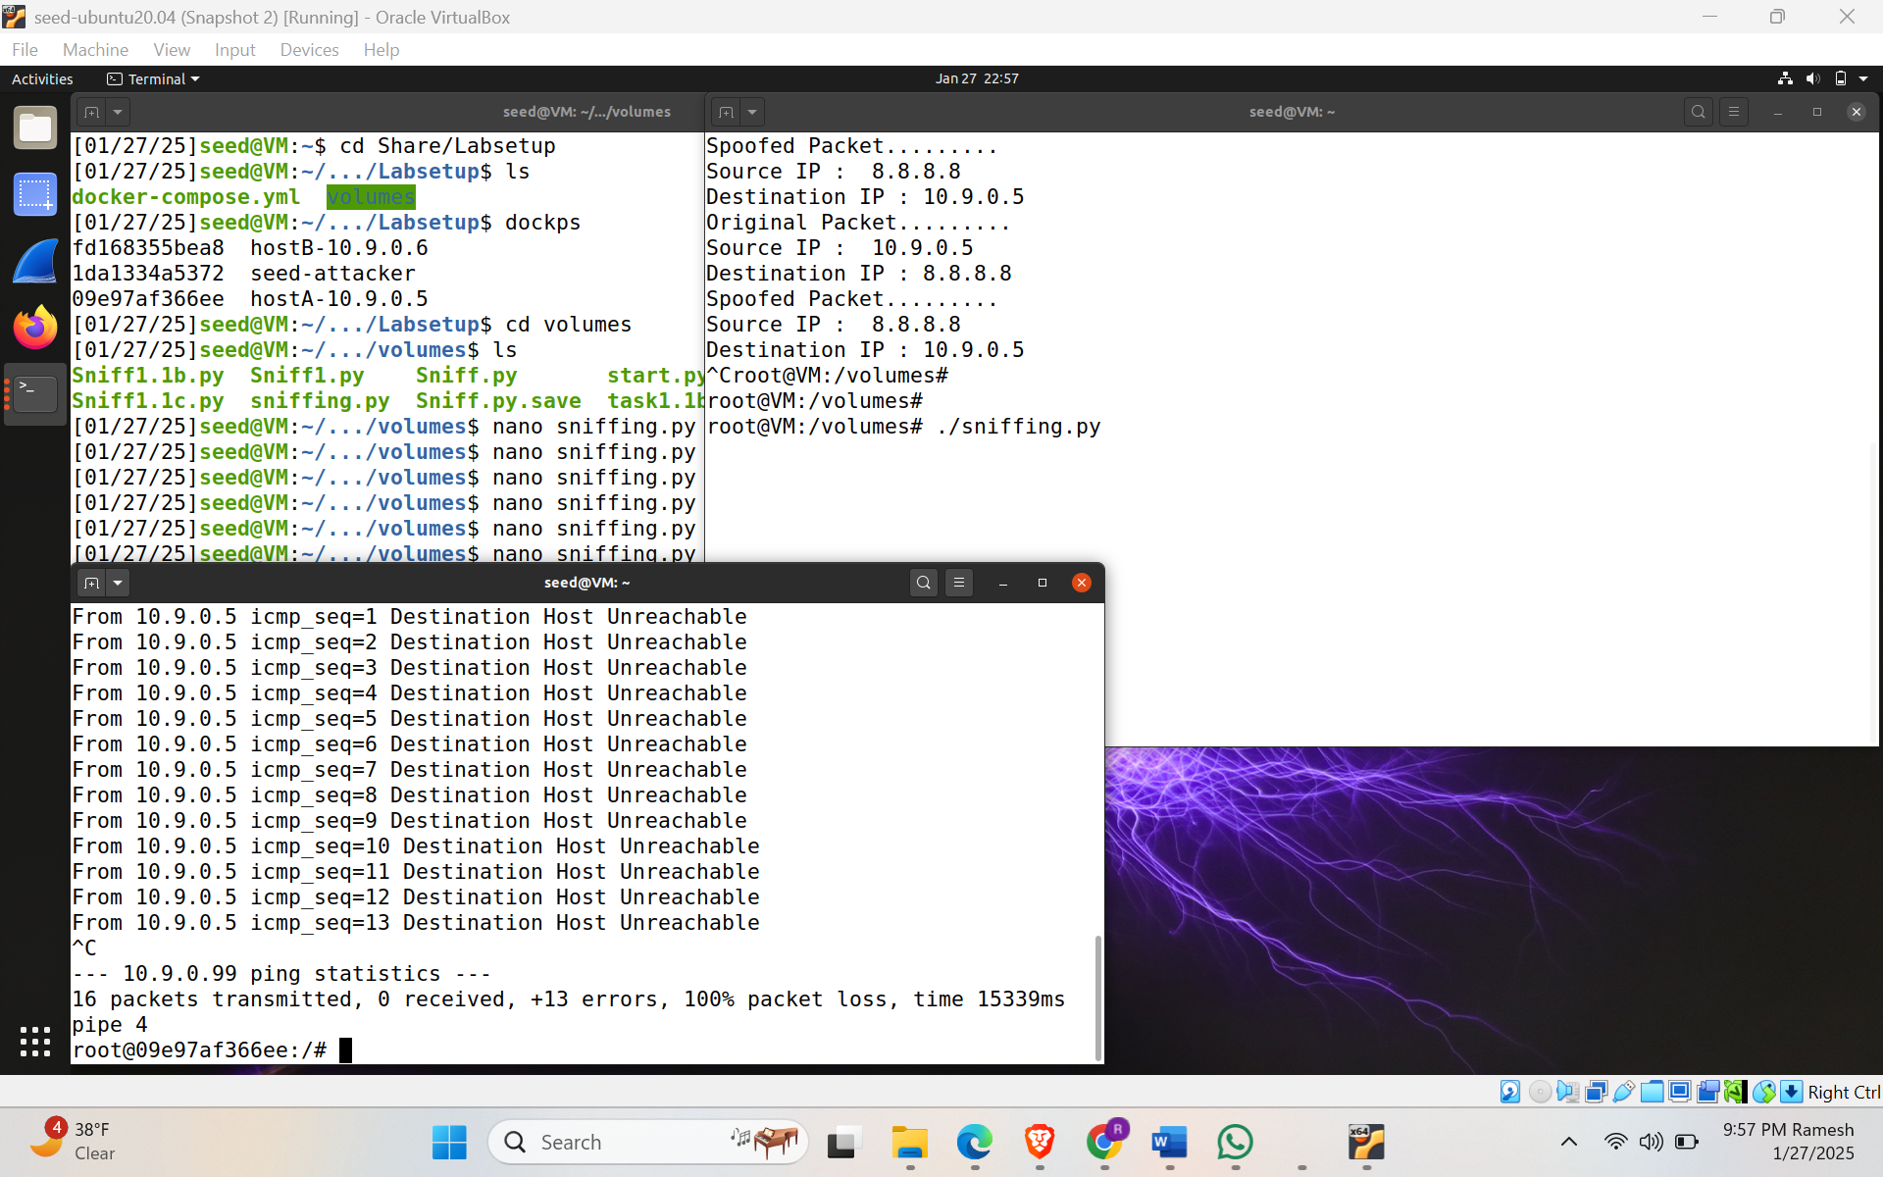

In scenario 3, we ping the IP 8.8.8.8 which is an existing host on the internet. In this case we get duplicate responses, because both real destination and the program responding back to the source.

